Certificate Number: **BGCL-XXXXXX**

**BHUTANGAP CERTIFICATE**

Certification Services, Bhutan Agriculture and Food Regulatory Authority

hereby certifies that produce of

**(Name of the farm)**

**(Location)**

are in accordance with the

**Control Points and Compliance Criteria as per the requirements of BhutanGAP Standard 2017 (BTS 30:2017) for primary production of …….. (mention specified fruit or vegetable)…..**

This certificate is valid for those produce(s) and area (s) specified below. (Use separate sheet for longer list)

|  |  |  |  |  |
| --- | --- | --- | --- | --- |
| **SN** | **Name of Produce** | **Production Area (Acre)** | **Production Quantity (Kg)** | **No. of Producer(s)** |
|  |  |  |  |  |
|  |  |  |  |  |
|  |  |  |  |  |
|  |  |  |  |  |
|  |  |  |  |  |

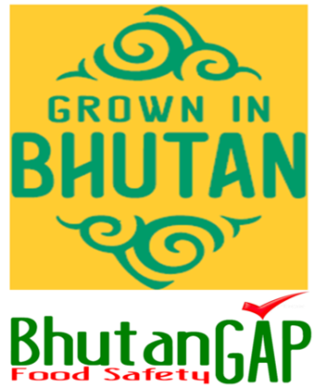Issue Date: **XXXXXXXX**Expiry Date: **XXXXXXXXXX**

**Dr. TashiSamdup**

**Director General/Head of Certification Body**

BTS 30:2017

